**Aggregate Report**

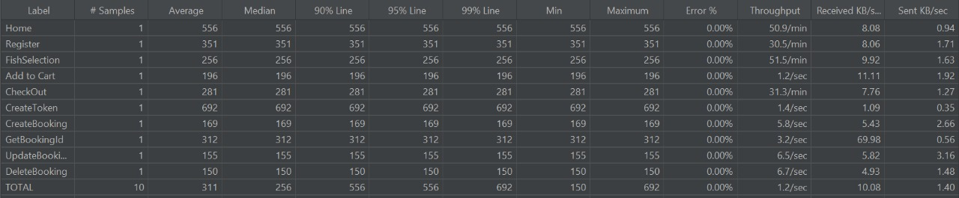

|  |  |
| --- | --- |
| The **total error percentage** for all samples must not exceed **(10 %)**. | 0.00% |
| At least **90%** of the **total** issued requests must not exceed **(3 seconds).** | 556ms |
| At least **99%** of requests must not exceed **(5 seconds).** | 692ms |